Aquatic Sector Career Quiz
Tick, circle, or colour your answer. At the end you’ll need to add up your score to find your career. Negative answers, like “-10” aren’t a wrong answer! They just help to calculate the final score. Make sure to think hard and answer honestly!

Q1 Do you prefer to work with a group or alone?
Alone | -10
I don’t mind | 0
Group | 20


Q2 If you had the choice, would you prefer to…
Go outside, even if it’s raining or snowing! | -50
I might go outside, if the weather is nice. | 70
Be inside, whatever the weather! | 140


Q3 On the playground, do you tend to organise others to play games, or go along with your friends’ plans?
I’m always organising games. | 7
Depends on the day – I can be both the organiser or the follower. | 0
I’m always going along with my friends’ plans. | -5

Q4 Do you enjoy making sense of the world around you and finding out why things happen, even if it’s hard work?
Yes | 0
No | 5

Q5 You are assigned a group project in class to build a sustainable Lego city. To get the project completed on time, do you…
Give everyone a different section to complete. | 3
Try to discuss a plan of action and talk about how to start. | 0
Sit back and let your teammates build whatever they want. | -3

Q6 It's Saturday and you've been allowed to make chocolate pancakes at home. Your first batch of pancakes are hard and chewy. You're allowed to try again to make them soft and fluffy. Do you...
Immediately try again and this time add baking powder to see if this works. | -4
Don't try again, and go do something else more interesting, like go to the park to meet your friends. | 4
Ask a grown up to come and help you get it right. | 0


Q7 Do you get bored doing repetitive tasks, or do you enjoy focusing on them?
I get bored | 0
I enjoy focusing | -5


Q8 Your class is heading off to Edinburgh Zoo on a school trip with another school. You are so excited to sit with your friends on the bus. When you get on, you are told there's been a mix up with pupils' numbers and you have to sit with pupils from another school that you do not know instead of your friends. Do you...
Plead with your teachers to let you move even though it's not possible. | 2
Chat to the new people and see it as a opportunity to make new friends. | 7
Sit in silence the whole way to Edinburgh because you are so mad that you're not with your friends. | -1

Q9 Do you enjoy sharing facts you’ve learnt with others?
Yes | 7
No | -3

Q10 You are on a school trip to the beach and see one of your classmates chasing seagulls, which isn't nice and means the birds have to use energy to fly away when they're trying to rest. Do you...
Tell a teacher. | -3
Tell your classmate not to chase them, and explain why. | 4
Say nothing to your classmate | 0
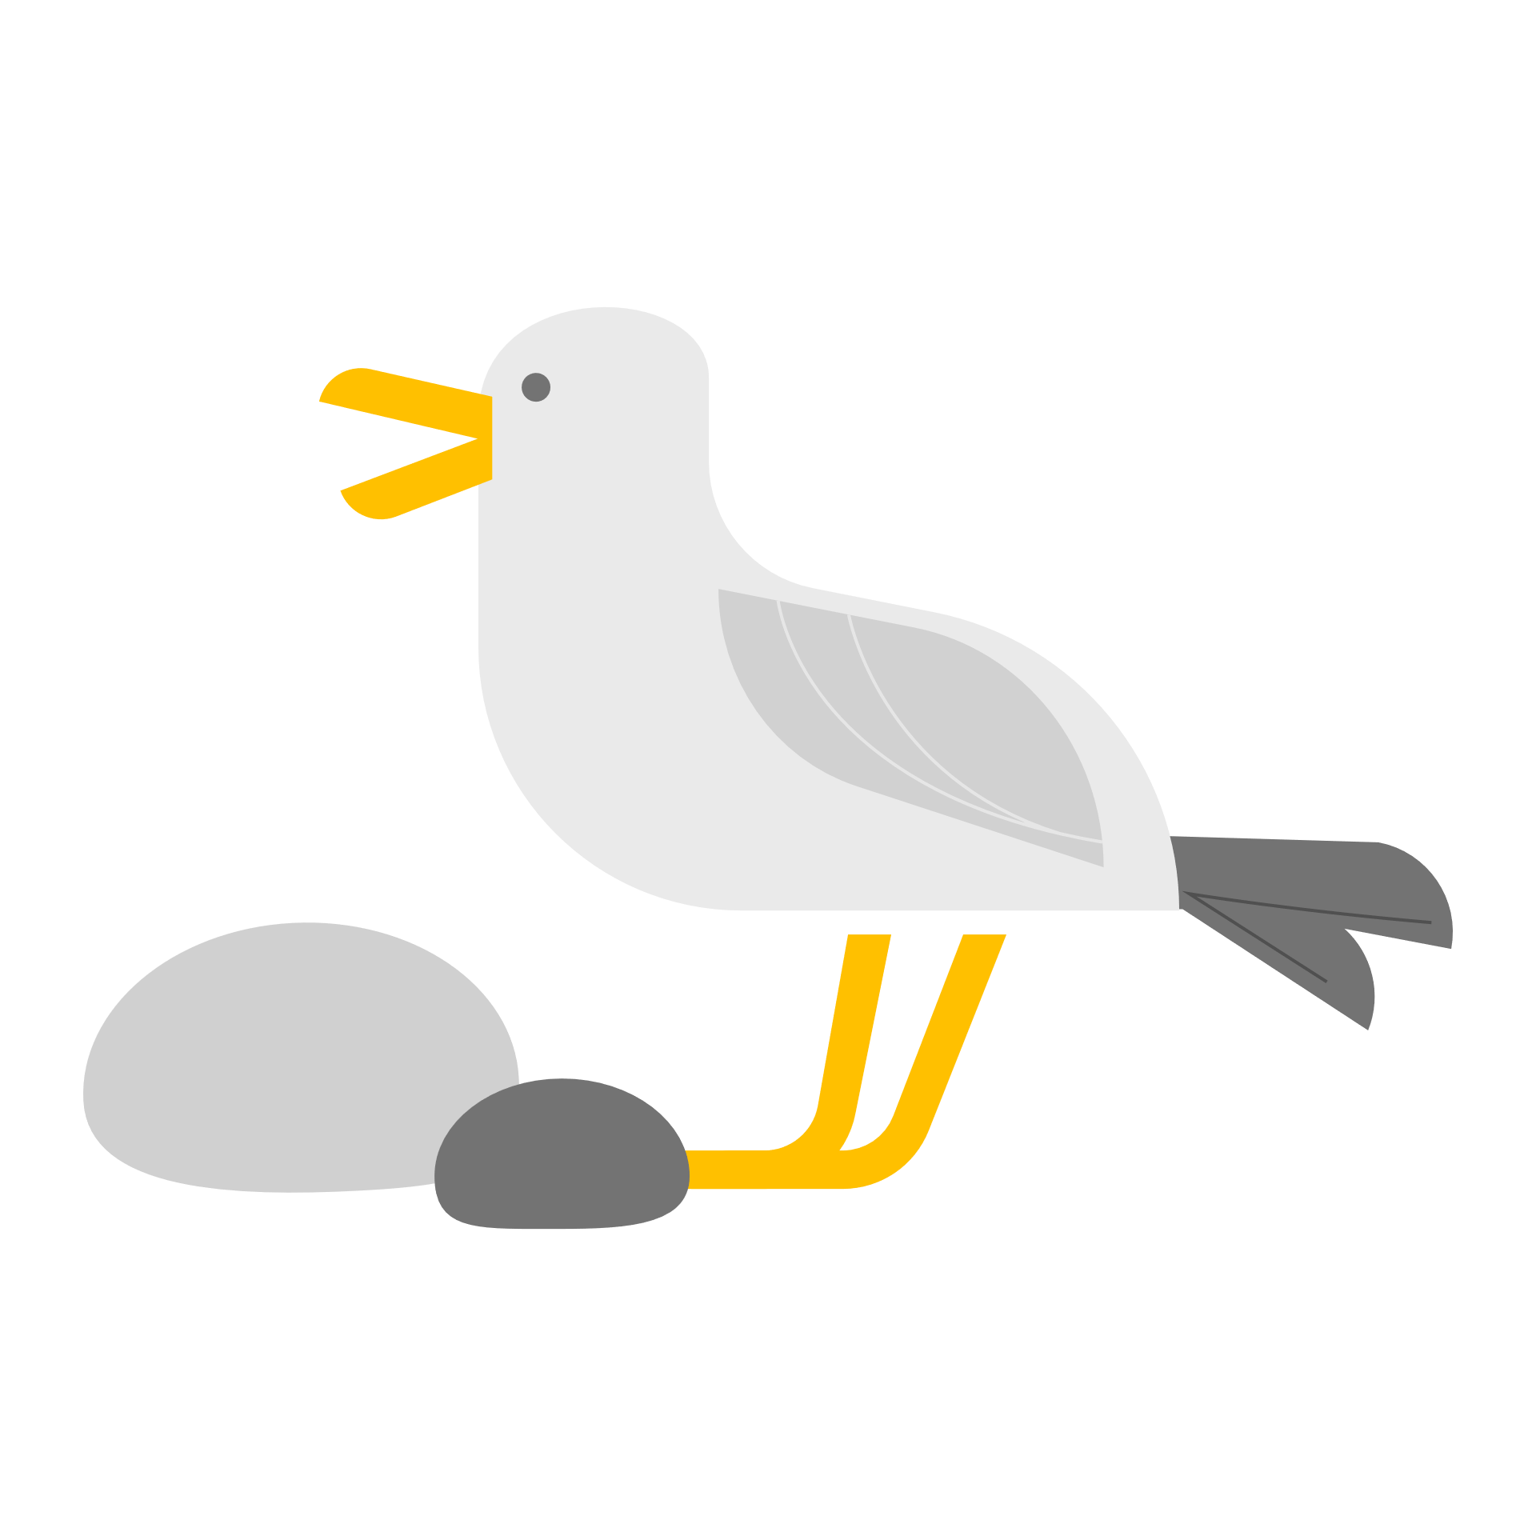

Q11 Pick the two options that you’d like to do best…
Visit lots of different places in the countryside | -2
Talk to lots of different people. | 4
Be in charge of vehicles or activities where you must keep people safe. | 2
Use science or maths to test new ways of helping the environment. | -4

Q12 Thinking about your meta-skills, which are your top three of this list?
Focusing | -3
Adapting | -1
Communicating | 1
Collaborating | 3
Curiosity | -2
Creativity | 2

Calculate your final score to find out the aquatic career that might fit you best!
-100 to -60 | Marine Biologist
-59 to -20 | River Health Officer
-19 to 20 | Beach School Leader
21 – 45 | Saltmarsh Restorer
46 – 70 | Tidal Power Engineer
71 – 95 | Power Boat Ecotour Driver
96 – 120 | Environmental Artist
121 – 145 | SCUBA Diver Instructor
146 – 185 | Lab Technician
186 – 214 | Remotely Operated Vehicle Driver
215 – 241 | Hydrologist
242 - 270 | Nature Education Officer

Career Bios (for teacher use – cut out to give to pupils when they finish)
Marine Biologist

The main aims of marine biology are to improve understanding of the marine/aquatic world and to understand changes in the oceans, rivers, coasts, and lakes especially changes caused by human development, climate change, or pollution.

Marine biology is a broad-ranging career. You could go into fieldwork, research, laboratory work, education/community outreach or policy making (working with the government).

River Health Officer

River health officers could be helping to protect and improve the biodiversity of our rivers. There may be particularly important species or habitats that you help to monitor.

This role could also work for the government to ensure that our rivers are clean and that there is no illegal dumping of waste or sewage from businesses and farming, which harms wildlife and can cause toxic plants to grow on our waterways.

Beach School Leader

Encourage child-led learning on coastal locations, bringing your knowledge of the environment and games to the class. You’ll prepare sessions that encourage children's resilience and meta-skills and find fun ways to use the beach and its natural resources to teach maths, English, and nature skills. You understand that connecting people to the natural world is needed for people to protect it.

Saltmarsh Restorer

Design and deliver restoration projects on saltmarshes. You’ll have a good understanding of the environment, ecosystems, habitats, and how water moves through the land. You'll work with teams, landowners, and contractors (who operate machines) to deliver the restoration. You will monitor how the restoration went and develop ways of improving methods for other saltmarshes.

Tidal Power Engineer

As a Tidal Energy Engineer, your main responsibility is to design, construct, and maintain tidal energy systems in order to generate electricity from the tides. You will need to be knowledgeable in various areas of engineering, including mechanical, electrical, and civil engineering. You will need to be able to analyse data and make decisions based on the findings. You will be responsible for researching and developing new technologies.

Power Boat Ecotour Driver

You'll get to show off the amazing coastlines of the UK to locals and tourists alike, sharing your knowledge about the special species and habitats as part of the tour - from rare seabirds to dolphins and whales. You might also share old legends and stories from the local area. You'll need to know how to pilot a powerboat and have a keen sense for risks and your responsibility to your passengers.

Environmental Artist

Collaborate with scientists, communities, and other creatives to raise awareness of and talk about environmental concerns, or to celebrate the environment in whatever creative style you are drawn to: paintings, clay models, sound recordings, creative writing, game design, video installations, clothes creation, and more - artists create thought-provoking and emotional pieces designed to start conversations or change opinions.

SCUBA Diver Instructor

SCUBA Diving Instructors are responsible for teaching students the necessary skills and knowledge to safely enjoy underwater diving. They are experienced divers themselves and know how to keep safe. You will also lead guided tours for other divers, perhaps exploring shipwrecks or special habitats.

Lab Technician

You will do research, collect data, and learn how to read data to understand what it is telling you. You might study animals or plants including their diseases, DNA, and habitats, or make experiments that test out new technologies or changes to the world and see how this affects living things.

You’ll write research papers and reports on what you find out, possibly for the public or other scientists.

Remotely Operated Vehicle Driver

You'll drive and maintain the robotic vehicle which goes underwater to take video and samples where human diving is limited. You'll play an important role in underwater inspections, repair, and exploration tasks. This position is important in industries such as scientific research, nature conservation, and tidal power development.

Hydrologist

Hydrologists study rainfall, rivers, and groundwater systems to help develop sustainable ways of managing water. Hydrologists collect data from waterways (like rivers) to address environmental challenges, and they will also work hard to make sure everyone understands the data. As a hydrologist, you might monitor, manage, and protect water resources for businesses, environmental organisations, or the government.

Nature Education Officer

This role is responsible for the development and delivery of fun and interesting education activities to help people learn more about Scotland’s marine and coastal environments and the spectacular ecosystems and wildlife we have. You'll ensure that everyone has an opportunity to engage with the Scottish marine environment and access to educational resources. You might visit schools or be based in a visitor centre for an environmental organisation like the Scottish Wildlife Trust or the Scottish Seabird Centre.

