Success Criteria | Self-assess
I can find the numbers I need in the table.
I can multiply them correctly.
I can say what my answer means in the real-world situation.

River Health
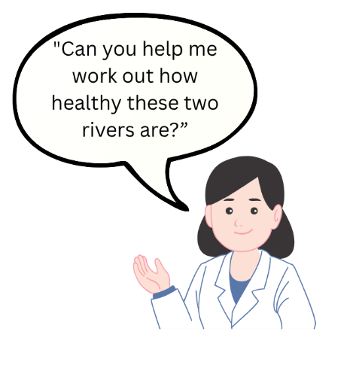
Each invertebrate is given a score based on how well it can survive pollution
Olivia is a scientist who studies rivers. She is investigating how healthy two rivers are by looking at the invertebrates living within them.

- Animals that live only in clean water = high score
- Animals that can live in dirty, polluted water = low score
Now, let’s use the table below to work out how healthy the river is:
- Multiply: Take each animal’s pollution score and multiply it by how many were found.
- Write it down: Fill in the last column with your answers.
- Add it up: Add up all the numbers in the number found column and in the last column
- Match your answer to the water quality scale below to see how healthy or unhealthy the river is.
Water Quality scale:
River Health | 0 – 1.9 | 2 – 3.9 | 4 – 5.9 | 6 – 7.9 | 8-10
Water Quality | Very Poor | Poor | Moderate | Good | Very Good

River Nith
Invertebrate | Pollution score | Number found in River | Total
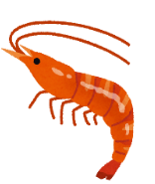  Freshwater  Shrimp | 5 | 3
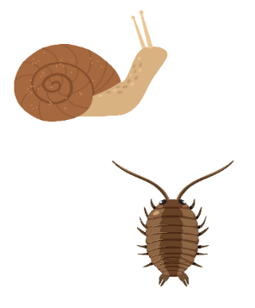  Water Louse | 3 | 5
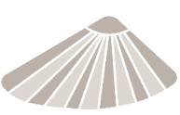  Limpet | 8 | 4
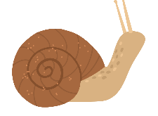  Snail | 3 | 7
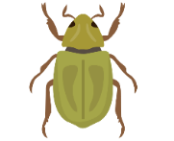  Beetle | 4 | 2
  Worm | 1 | 9
 | Total

Now, let’s work out the river’s health score
- Add up all the “Number Found” to get the total animals =

- Add up all the “Total Scores” from the last column =

- Divide the total score by the total number of animals for River Health Score =


“Now check the Water Quality scale! Match your score to see how clean or dirty the water is!”

- What is the river Nith’s Water Quality value? =
Compare with the River Dee
Repeat the same steps for the River Dee table

River Dee
Invertebrate | Pollution score | Number found in river | Total
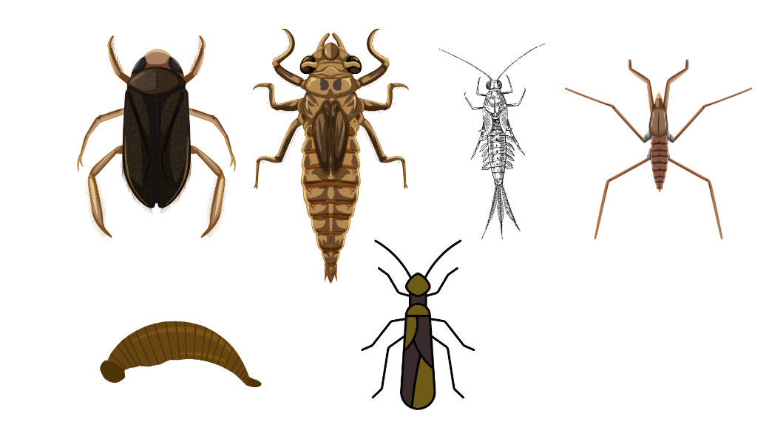  Stonefly larvae | 9 | 3
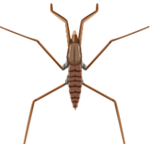  Pond Skater | 5 | 9
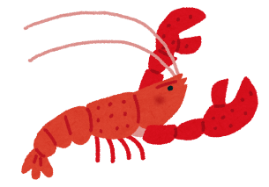  Freshwater Crayfish | 10 | 9
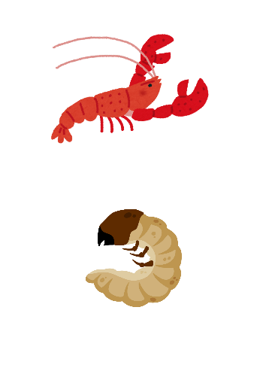  Cased caddisfly larvae | 7 | 2
Total =

- What is the river health score? (Remember: divide the total score by the total number of animals) =

- What is the water quality value? (use the scale above) =

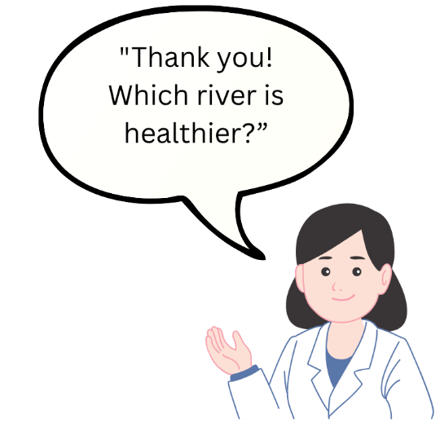
- The heathiest river =

